MCCP6020 Advanced English for Academic Purposes

Independent Language Learning Guide
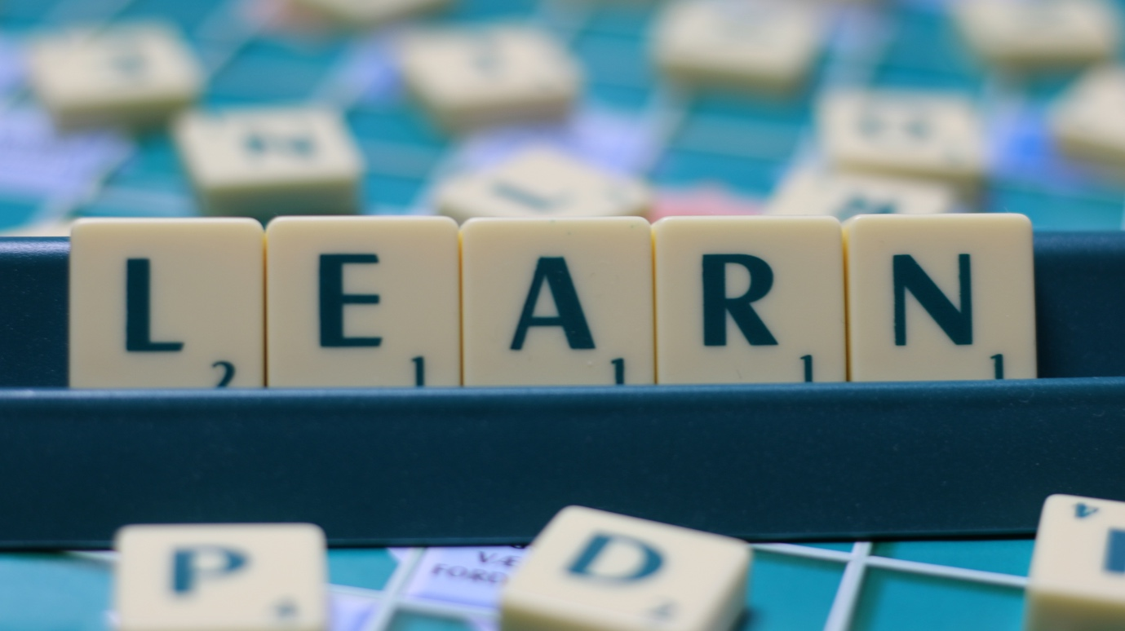

Table of Contents
1. How should I use the Independent Language Learning Guide? 2
2. What is Independent Language Learning? 2
3. Setting SMART learning goals 3
4. What is reflection and why it matters? 5
5. Online Language Learning Materials 7
6. APPENDIX I: PROOFREADING CHECKLIST 11
7. Appendix II: Thesis Writing Checklist 13

How should I use the Independent Language Learning Guide?
This guide aims to give you some suggestions about language learning methods and materials for Independent Language Learning. The suggestions are not a complete list. You are expected to look beyond those suggested. You can think of this guide as a manual which you can dip into when you need to. In addition to using the readily available online language learning materials, we strongly recommend that you use the language learning resources and support services offered by the Language Centre to improve your language skills. You may visit this website for more details: https://lc.hkbu.edu.hk/sall/english/

What is Independent Language Learning?
Independent language learning is a way of learning where you become increasingly more responsible for your own learning both inside and outside of the classroom and aims to make learners more independent and autonomous. In other words, it means “learning how to learn” more effectively. The skills you develop from independent learning would prepare you to become a lifelong learner. Independent language learning requires you to:
- investigate and decide what you need to or want to learn (your learning goals plan created early in the course);
- find and select materials and methods you will use to achieve those learning goals;
- keep yourself motivated and deal with your emotions;
- evaluate the effectiveness and suitability of the materials and methods you have selected in achieving your learning goals as well as evaluating your own language ability and effectiveness as a learner;
- manage how best to cooperate, collaborate and draw on the support and guidance of others in reaching your goals (e.g. teachers, language advisors, classmates, friends);
- monitor your progress toward achieving your learning goals and meeting the aims of your plan;
- reflect on your learning experiences to guide you towards more effective goals, materials, learning methods, means of monitoring, ways of evaluating, as well as further developing your ability to reflect; and
- ultimately become more responsible, independent and autonomous in your learning.
Independent language learning mainly involves three key skills. The learning process is cyclical:
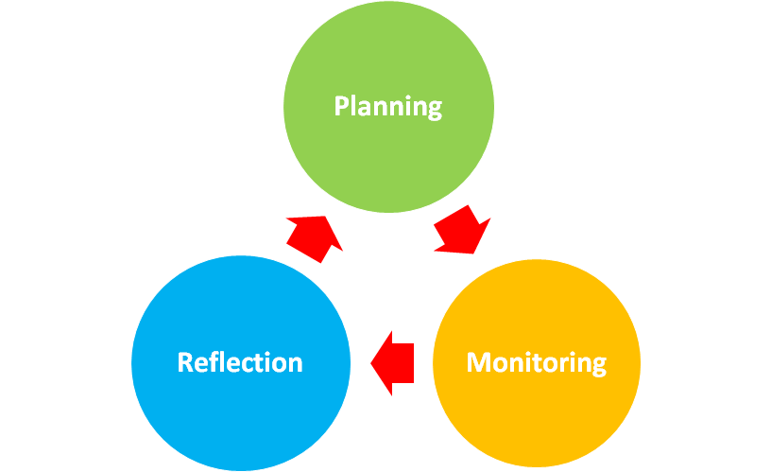
- Independent Language Learning Goals Plan
- In-class Sharing of Independent Language Learning Progress
- Individual Consultations with the Lecturers and Language Advisors

- Reflective journals
- Self-assessment of performance and learning progress

Setting SMART learning goals

Your learning goals should be S.M.A.R.T. Read the following explanations below to understand what this acronym means and how to apply it to your independent language learning goals.
S – Specific
There are a few ways to make your goal(s) specific:
- Make your goal a sub-skill of one of the general language skills areas (e.g. listening, speaking, reading, writing) that relates to some kind of specific written or spoken text. For example, if you want to work on your academic writing skills, your goal could be: “increase the range of sentence structures in journal article/thesis writing (specific written text)”.
- Work on a ‘transferrable’ sub-skill. This is a sub-skill that can be used in various aspects of your English. The most common example of a ‘transferrable’ sub-skill is the grammar skills.
M- Measurable
To make your goal measurable, you can:
- Do something you need to improve or you need to do in the future (e.g. abstract writing for conference application, writing a manuscript for journal publication)
- Complete a certain amount of learning (e.g. have learned 40 academic vocabulary items in your discipline; have written two sections of a manuscript for journal publication)
A – Achievable
Your goal(s) should be realistic. Do not expect after 10 hours of independent learning you will be a fluent speaker of English. Discuss your goal(s) with your lecturer in the individual consultations.
R – Relevant
Your goal should clearly relate to some kind of purpose (academic, professional, everyday) and / or a language needs. Do not waste time on goals that do not help you improve in some way related to your learning needs or purposes.
Your goal should be a real goal and not an activity. For example, your goal should not be “reading a journal article every day”. Reading journal articles is an activity that helps you achieve a goal e.g. Be able to use complex sentence structures in academic writing.
T – Time-bound
Your learning goal should be achievable within the time frame you have. For this course, you will only be working on short-term goals. However, after this course finishes, you may want to continue with independent language learning and set yourself mid-term goals (a few months to a couple of years) or even long-term goals (several years, e.g. maybe lifelong learning goals that will help you with your career).
Here are some examples of SMART goals:
- To use pronunciation features (e.g. stress and intonation, speech chunks) appropriately for different purposes in academic presentations.
- To use a range of sentence structures in academic writing.
- To improve cohesion and coherence in academic writing.
- To present my ideas in a more organized way when handling questions from the audience in academic presentations and when giving spontaneous speeches.
Now complete your independent language learning goal plan:
GOAL 1
General Skills Area:
Highlight which general skills area(s) your goal relates to.
Listening Speaking Reading Writing Grammar Vocabulary
Specific Goal:

Rationale (In terms of one or more of the following: purpose, language needs, learner style, motivation):

Possible materials (i.e. resources) and methods (i.e. activities, strategies, techniques). Refer to independent language learning resource list (available on Moodle) for ideas.

Anticipated outcome or progress (What do you expect to achieve by the end of the course?)

Estimated Time Needed (in hours or days):

What is reflection and why it matters?

According to the educationalist Graham Gibbs (1988), reflection involves six distinct stages within a cycle. The cycle is designed to create a ‘virtuous circle’ whereby reflection leads to greater improvement in the future:

Why is reflection important for you and your learning?
- Reflection helps you make links between what you learn and how it is actually used in the real world; it also helps integrate new knowledge with previous knowledge and develop your understanding.

- Reflecting on and learning from your experiences, including your mistakes, can help you avoid repeated mistakes and, at the same time, identify successful aspects of an experience and principles which might usefully be applied to other situations.

- Reflection gives you the chance to explore thoughts and feelings, work through difficult or painful experiences, develop self-awareness and bring out fresh insights.

- Reflection can help you get away from routine, automatic action and make conscious and informed decisions after weighing up all aspects of a situation.

- Reflection is highly valued in both academia and in most professions.

To help you reflect on your learning, you may use the following template to keep a record of your learning:
Date/time:
Put the length of time / duration of the activity
Noting the time is useful because you may find you work more effectively at certain times of the day or night.
Learning goal:
Put the Specific Learning Goal that you were working toward in this session.
What materials I used:
Note or describe which resource(s) you used. Make sure that there is enough information so that you can find or recreate that resource / activity again.
- For books and/or readings, give the title, year and author
- For films and other audio-visual materials give the title and year
- For online materials give the title, the website and note the URL
What I did with it & why (Description & Rationale):
- Describe what you did and the method(s) that you applied.
- Outline the procedure you followed for the activity, pathway, strategy or technique.
- Give clear reasons for your choice of materials and methods.
Reflection:
STAGE 1 (Description – see What I used and What I did with & why above):
- Did you learn anything? What?
STAGE 2 (Thoughts and feelings):
- Did you enjoy it or find it motivating? Why? / Why not? What other feelings or thoughts did you have?
STAGE 3 (Evaluation):
- Was the material and/or method worth the time you spent? Why? / Why not
- How does this material and/or method compare with other ones that you have tried for this learning goal?
- Did it help you toward your learning goal? How effective was it?
STAGE 4 (Analysis):
- What do other people who have tried this material / method think? Do you agree with their views? Why? / Why not?
- Did the time and place of your learning affect the way / how much you learned? How do you know?
STAGE 5 (Improvements):
- Could you make the experience/learning better? How?
STAGE 6 (Future Plan):
- Would you use this material and/or method again? Why / Why not?
- What materials and/or methods will you use next time?
OTHER COMMENTS:

Online Language Learning Materials

MATERIALS FOR SPEAKING SKILLS
Online Pronunciation Exercises and Activities  Giving Academic Presentations | UEfAP Speaking in Academic Contexts: Pronunciation  BBC Learning English Pronunciation Tips  Pronunciation Videos on YouTube  English Club: Learning English pronunciation  Learning English Online: Stress and Intonation  University of Technology Sydney: Conference presentations  Harvard Business Review: How to Give a Killer Presentation  Tips for Presenting Your Scientific Poster at a Conference  Tips for Making a Poster Presentation  5 Ways to Present Your Point with Power, Not Just PowerPoint | These sites offer information on pronunciation, the International Phonetic Alphabet (IPA), and numerous exercises and activities to help improve the accuracy of your pronunciation. You can also check on YouTube for various video guides on IPA, different accents of English, and more!  These sites offer tips and advice on giving academic presentations at conferences

MATERIALS FOR WRITING SKILLS
Academic Writing  Manuscript Writing for Journal Publication  Corpus-assisted Research Writing | Harvard College Writing Centre: Strategies for Essay Writing  Monash University Research and Learning Online: Academic Writing  - Features of academic writing  - Clear communication  - Paraphrasing, summarising and quoting  - Editing and proofreading  BBC Learning English – Go the Distance: Academic Writing  Purdue University Online Writing Lab: Academic Writing Skills  Elements of Style for Writing Scientific Journal Articles  Taylor & Francis: How to Write and Structure a Journal Article  Standard Structure of a Medical Research Article and Peer Review  A Move-step Analysis of the Concluding Chapters in Computer Science PhD Theses  Nature Education: English Communication for Scientists  University of Glasgow - Writing for Scholarly Journals: Publishing in the Arts, Humanities and Social Sciences  Using Strong Verbs for Research Writing  The Guardian: How to Get Published in an Academic Journals: Top Tips from Editors  Elsevier: How to Get Your Research Published…and Then Noticed  BNCweb Corpus  AntConc  Tutorial video on AntConc | These sites offer information and tips on academic writing.  These sites offer information and tips on journal article publication

MATERIALS FOR GRAMMAR SKILLS
Grammar Exercises and Explanations | Purdue Online Writing Lab: Grammar  HKUST The English Grammar Guide (The EGG)  Purdue Online Writing Lab: Sentence Clarity  Sentence Structure and Types of Sentences  Coherence and Cohesion  British Council: Grammar for Intermediate to Upper Intermediate Learner of English | These sites give short and clear explanations and there are online exercises to help you.

APPENDIX I: PROOFREADING CHECKLIST

The following checklist shows the common errors found in students’ writing. Use this checklist as a proofreading guide for your writing.
Ap | Appropriacy  Mixed up tone or formality. This style/ word / phrase / sentence is not suitable for this type of situation / text / reader.
Art | Articles  a/an/the is wrong, missing or unnecessary
Cit | Citation / Reference  This citation or reference has been written incorrectly or wrongly formatted. (Note: Formats vary widely so check with your professors)
Co | Collocation  Words that go together in certain patterns. A very common source of error.
GP | Gerund / Participle Patterns  The type of verbs (e.g. infinitive, gerund) following this adjective, noun, phrase or verb is wrong. Or, mixing up ‘ed’ & ‘ing’ participles and adjectives.
GR | Grammar mistake  Miscellaneous grammar mistakes that do not fall under another category
H | Hedging  This claim, fact, point, statement, conclusion etc. needs to be hedged. Hedging shows levels of (un)certainty.
Md | Modal Verb  Wrong modal verb and / or grammatical problems with the modal verb.
P | Punctuation  Mistakes with commas, capital letters, full-stops, colons, semi-colons, question marks etc.
Pr | Preposition  Wrong, missing or unnecessary preposition
Rf | Referencing  Confusing use of pronouns, determiners and other words and phrases which are used to refer to things backwards and forwards in a text
Sgl | Singular/Plural Nouns  Mixing up singular and plural nouns
Sp | Spelling  Use spell checks on your computer!
Snt | Sentence structure  Problems with simple, compound and complex sentences and/or linking devices.
SV | Subject / Verb Agreement  The verb does not match the subject of the sentence.
T | Tense Problems  The tense is wrong or the form of the verb has been written incorrectly.
UC | Uncountable / Countable Nouns  Mixing up countable and uncountable nouns and quantifiers.
VV | Verb Voice  Mixing up active & passive voice.
WF | Word Form  Mixing up nouns, adjectives, adverbs, nouns & verbs
WO | Word Order  Mixing up the order and position of words especially adverbs.
WW | Wrong Word  The meaning of this word is wrong.

Appendix II: Thesis Writing Checklist

The following checklist will help you evaluate the quality of your thesis and your academic competencies:
Criteria | Yes / No?
Theoretical framework
- The research question draws on relevant and recent literature.
- The findings are linked to the literature and the theoretical framework.
- The student’s own work engages with the existing literature.

Research questions/hypotheses
- The research questions/hypotheses are relevant and specific.
- The research is driven by the research questions/hypotheses.

Research method
- The research method is adequate and thorough.
- The research method is justified.
- The data analysis (where applicable) is adequate.

Conclusions and critical reflection
- The conclusions are valid and have been critically reflected upon.
- The study makes a meaningful contribution to research in the discipline.
- The thesis demonstrates academic integrity.
- The conclusions highlight the originality and novelty of the research.

Structure
- The different parts/chapters of the thesis are structured logically and coherently.
- The thesis demonstrates the student’s analytical and synthetic ability.
- The thesis reflects a critical scientific attitude.

Presentation and style
- The formal requirement is used for tables, figures and references.
- Correct spelling is used.
- Language use and sentence structures are correct.
- The thesis meets presentation standards.
- Formal academic style is used (neutral, critical, objective, well-argued)

Gibbs, G. (1988). Learning by doing: A guide to teaching and learning methods. Oxford Polytechnic.

